Mack Truck – Macungie, PA

Cab Paint Line Modification – Control System

Operating Instructions:
Clean Room Equipment
- Clean Room Air Supply House
  - Circulation Fan
  - Chilled Water Coil Flow Control Valve (modulating)
    - Motorized Valve modulation for temperature control of supply air to Clean Room
- Chilled Water Circulation Pump
  - Start/Stop Permissive Interlock to Chiller Unit for control
  - Pump Motor Running Interlock for monitoring
  - Chiller System 1-2 and 3 Fault Interlocks for monitoring
- Glycol Pump
  - Pump Motor Running Interlock for monitoring
- Control Panel

CP1
Figure 1

Manual Operation –
- Position Clean Room Air Supply House Circulation Fan local motor disconnect switch to the “ON” position
  - Local disconnect switch in the off position is monitored and displayed on the system HMI.

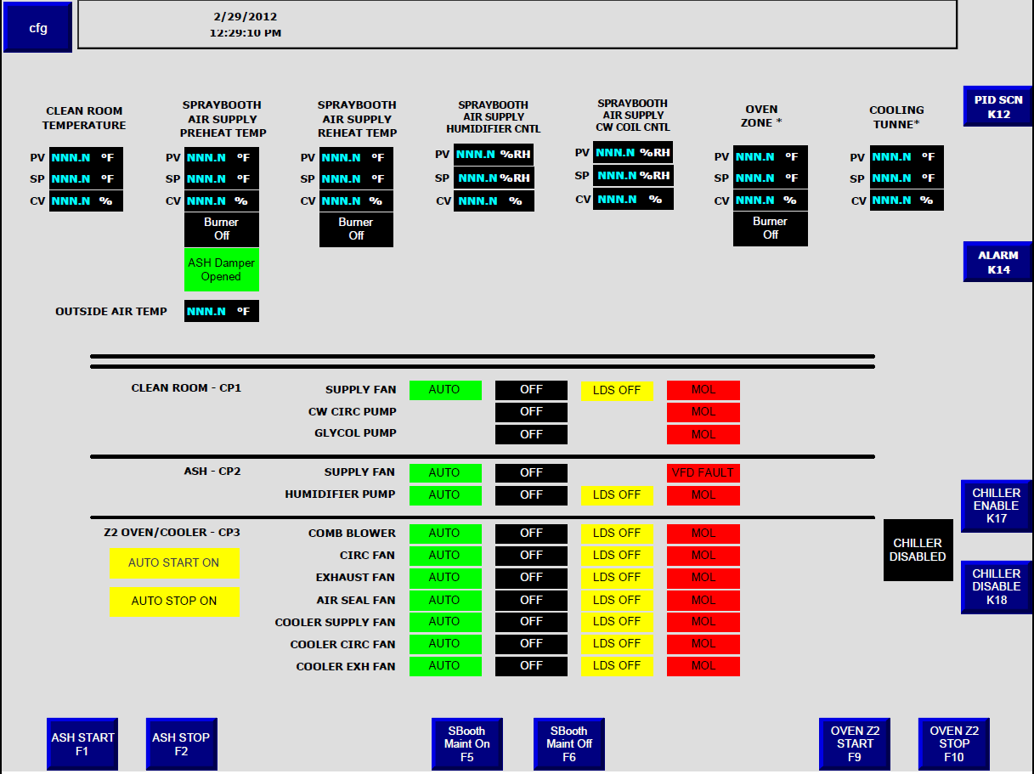
Figure 2

- Locate control panel “Reset” pushbutton on the control panel door and push to reset any existing faults.
- Locate Circulation Fan Start Selector Switch on the control panel door and turn to start position. The selector switch will return to “Enable” position when released. The enable position is the normal operating position. The selector switch “Off” position is used to disable fan starting. This is typical for all systems.
- Once the circulation fan is started the temperature control is enabled in the PLC and Clean Room temperature will be cooled to operator entered set point.
  - Chilled water coil modulating control valve operation is controlled by the PLC and controls the amount of chilled water passing through the chilled water coil to control Clean Room temperature.
  - System is only capable of cooling. System heating is not available.
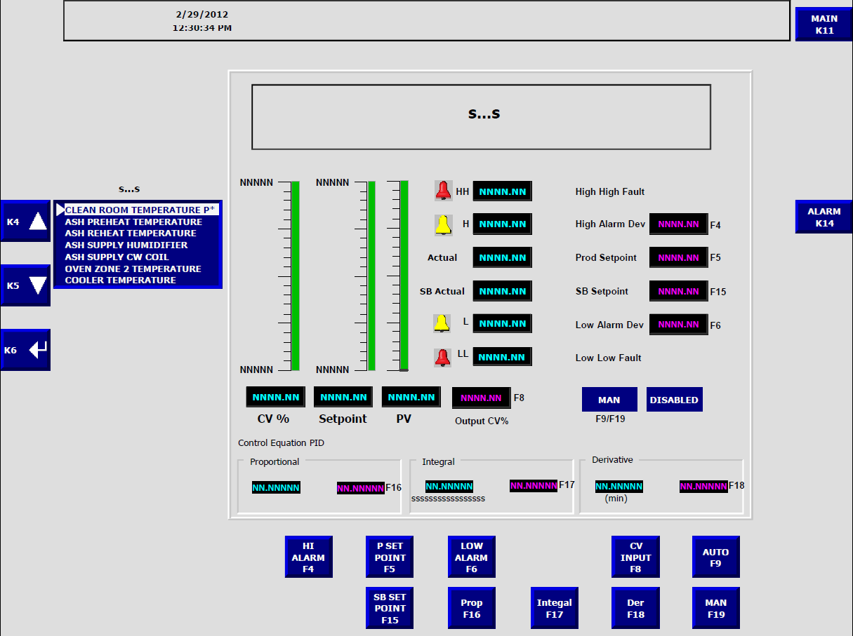
Figure 3

- Pressing Function Key F5 will open up a keyboard screen in which the operator can enter production setpoint. This is typical for all systems

Automatic Operation –
Same as Manual Operation

Operating Instructions:
Spraybooth Air Supply House Equipment

- Air Supply House
  - Supply Fan
    - Start/Stop Permissive Interlock to existing Supply Fan VFD
    - Supply Fan VFD Running Interlock from existing VFD for monitoring
    - Supply Fan Fault Interlocks from existing VFD for monitoring
  - Humidifier Circulation Pump
  - Humidifier – 4 bank system with 0n/Off solenoid valves
  - Outside Air Intake Dampers (2-position)
  - Chilled Water Coil Flow Control Valve (modulating)
  - Motorized Valve modulation for temperature control of supply air to Spraybooth
  - Preheat Burner System (2-Stage)
  - Reheat Burner System
- Control Panel

CP2
Figure 4

Manual Operation –
- Position Humidifier Circulation Pump local motor disconnect to the “ON” position
Local disconnect switch in the off position is monitored and displayed on the system HMI.
- Locate the “Reset” pushbutton on the control panel door and push to reset any existing faults.
- Position the Preheat burner “Auto/Manual” selector switch to the Manual Position.
- Position the Reheat burner “Auto/Manual” selector switch to the Manual Position.
- Locate The Supply Fan start Selector Switch on the control panel door and turn to “start” position.
  - Initiating a Supply Fan start will first open the Outside Air dampers.
  - When the outside air dampers are proven open a Supply Fan start interlock signal is sent to the existing Spraybooth Supply Fan VFD controller.
  - Air Flow proven switches across the preheat and reheat burners prove airflow and hence the Supply Fan is running.
  - Once the Outside air dampers are open, the Supply Fan is Running and the burner airflow switches are proven, the preheat flame relay control is enabled and the flame relay start cycle is initiated.
  - Once the flame relay start cycle and purge timer are complete the flame relay display will show the “Start Switch” on the screen indicating that a manual start can be initiated.
- Locate the Preheat Burner Start pushbutton on the control panel door and push it to initiate the burner start sequence.
  - Preheat burner stage one will light and the flame relay will go through a flame on proof sequence prior to opening the main gas valve.
  - Once the flame relay has established the flame is good, the main gas valve is opened and the temperature control in the PLC is enabled.
  - The preheat burner temperature control will operate automatically and control the gas trane gas modulating control valve to maintain the operator setpoint temperature. This temperature is measures prior to the first set of filters in the Air Supply House. If the Preheat temperature control output is held above a predetermined level for a predetermined time the stage two flame relay is enabled.
  - Once the stage two flame relay start cycle and purge timer are complete the flame relay starts the stage two burner, by opening the stage two main valve, automatically.
  - Preheat burner stage two will light and the flame relay will go through a flame on proof sequence.
  - Once the flame relay has established the flame is good the main gas valve for stage two is kept on.
  - The burner can be stopped by pressing the “Burner Stop” pushbutton.

- Locate the Reheat Burner Start pushbutton on the control panel door and push it to initiate the burner start sequence.
  - Reheat burner stage one will light and the flame relay will go through a flame on proof sequence prior to opening the main gas valve.
  - Once the flame relay has established the flame is good then the main gas valve is opened and the temperature control in the PLC is enabled.
  - The reheat burner temperature control will operate automatically and control the gas trane gas modulating control valve to maintain the operator setpoint temperature. This temperature is measures in the ASH supply duct prior to the Air Supply House Plenum.
  - The burner can be stopped by pressing the “Burner Stop” pushbutton.

- The Air Supply House Humidification system operates automatically based on operator setpoint.
  - Based on operator setpoint the 4-bank humidifier system solenoids open and close according to actual measured %RH. The PLC controls the operation of the solenoids to maintain humidity setpoint inside the spraybooth during dry outside air conditions. The Humidity is measures in the ASH supply duct prior to the spraybooth plenum.
- The air Supply House DeHumidification system operates automatically based on operator setpoint.
  - Based on operator setpoint the DeHumidification system modulates the chilled water control valve open and closed according to measured %RH to maintain humidity setpoint inside the spraybooth.
Note: A 10%RH deadband should be maintained for proper operation of the Humidification and dehumidification systems.

Automatic Operation –
Manual and Automatic operation of the system is the same except that the burner “Auto/Manual” selector switches are set to “Automatic” and the Supply Fan and Humidifier Recirc Pump “Off/Enable/Start” selector switches are set to “Enable”. No manual start of the burners or fans is required. Auto Start is initiated through the HMI on CP1. The PLC controls the starting and stopping of the burners.

Auto Sequence Start –
Automatic Sequence start for this system can be initiated from the HMI main screen on CP1. Pressing Function Key F1 “ASH Start” will start the system through the PLC automatically. A system auto sequence can be started by pressing Function Key F2 “ASH Stop”

Figure 5
Maintence Mode –
Spraybooth maintenance operating temperature can be turned on by pressing Function Key F5 “SB Maint On” and turned off by pressing Function Key F6 “SB Maint Off”

Figure 6
Operating Instructions:
Oven Zone 2 and Cooler
Equipment
- Oven Zone 2
  - Circulation Fan
  - Exhaust Fan
  - Combustion Blower
  - Exit Air Seal Fan

2) Cooler Air Suply House
  - Cooler Supply Fan
  - Cooler Exhaust Fan
  - Cooler Recirc Fan
  - Cooler Chilled Water Control Valve (modulating)

- Control Panel

CP3
Figure 7

Manual Operation –
- Position Oven Zone 2 Circulation Fan local motor disconnect to the “ON” position
Local disconnect switch in the off position is monitored and displayed on the system HMI.
- Position Oven Zone 2 Exhaust Fan local motor disconnect to the “ON” position
Local disconnect switch in the off position is monitored and displayed on the system HMI.
- Position Zone 2 Burner Combustion Blower local motor disconnect to the “ON” position
Local disconnect switch in the off position is monitored and displayed on the system HMI.
- Position Oven Zone 2 Exit Air Seal Fan local motor disconnect to the “ON” position
Local disconnect switch in the off position is monitored and displayed on the system HMI
- Position Cooler Supply Fan local motor disconnect to the “ON” position
Local disconnect switch in the off position is monitored and displayed on the system HMI.
- Position Cooler Exhaust Fan local motor disconnect to the “ON” position
Local disconnect switch in the off position is monitored and displayed on the system HMI.
- Position Cooler Recirc Fan local motor disconnect to the “ON” position
Local disconnect switch in the off position is monitored and displayed on the system HMI.
- Locate the “Reset” pushbutton on the control panel door and push to reset any existing faults.
- Position the Zone 2 burner “Auto/Manual” selector switch to the Manual Position.
- Locate the Zone 2 Recirc Fan start Selector Switch on the control panel door and turn to “start” position.
- Locate the Zone 2 Exhaust Fan start Selector Switch on the control panel door and turn to “start” position.
- Locate the Zone 2 Burner Combustion Blower start Selector Switch on the control panel door and turn to “start” position.
- Locate the Zone 2 Oven Exit Air Seal Fan start Selector Switch on the control panel door and turn to “start” position.
- Locate the Zone 2 Recirc Fan start Selector Switch on the control panel door and turn to “start” position.
- Locate the Cooler Supply Fan start Selector Switch on the control panel door and turn to “start” position.
- Locate the Cooler Recirc Fan start Selector Switch on the control panel door and turn to “start” position.
- Locate the Cooler Exhaust Fan start Selector Switch on the control panel door and turn to “start” position.
- Once the Oven Zone 2 Recirc Fan, Exhaust Fan and Combustion Blower are started and each of their Air Flow Switches is proven a Zone 2 Purge timer is enabled. The zone 2 purge timer duration is approximately 8 minutes. Stopping any of these three fan or loss of any air flow switch proven signal will restart the zone 2 purge timer.
- Completion of the zone 2 purge timer enables burner flame relay start sequence
  - Once the flame relay start cycle and purge timer are complete the flame relay display will show the “Start Signal” on the screen indicating that a manual start can be initiated.
  - Pressing the burner start pushbutton will light the burner and the flame relay will go through a flame on proof sequence.
  - Once the flame relay has established the flame is established the main gas valve is opened
  - The burner temperature control will operate automatically and control the gas trane gas modulating control valve to maintain the operator setpoint temperature.
  - The burner can be stopped by pressing the “Burner Stop” pushbutton.
- Starting the cooler supply fan will enable the Cooler PLC temperature control and maintain operator setpoint.

Automatic Operation –
Manual and Automatic operation of the system is the same except that the burner “Auto/Manual” selector switch is set to “Automatic” and all fan “Off/Enable/Start” selector switches are set to “Enable”. No manual start of the burner is required. The PLC controls the starting and stopping of the fans and burner. An Auto Start through the HMI in CP! Is required.

Auto Sequence Start –
Automatic Sequence start for this system can be initiated from the HMI main screen on CP1. Pressing Function Key F9 “Oven Zone 2 Start” will start the system through the PLC automatically. A system auto sequence can be started by pressing Function Key F10 “Oven Zone 2 Stop”

Figure 8
HMI (Human Machine Interface)
Main Screen

PID PARAMETER DISPLAY AREA

MOTOR STATUS DISPLAY AREA
BURNER STATUS

OUTSIDE AIR DAMPER STATUS

CHILLER STATUS
Figure 9
Function Key Legend:
Cfg- Return to configuration screen
F1- ASH START – Air Supply House auto start
F2- ASH STOP – Air Supply House Auto Stop
F5- SBooth Maint On – Set ASH temperatures to maintenance setpoints
F6- SBooth Maint Off – Return ASH temperatures to production setpoints
F9- OVEN Z2 START – Start Oven Zone 2 Automatically
F10- OVEN Z2 STOP – Stop Oven Zone 2 Automatically
K12- Go to PID setup screen
K14- Go to alarm screen
K17- Enable Chiller operation
K18- Disable Chiller operation

PID Screen

PID PULLDON SELECTION MENU

Figure 10
PID AND ALARM PARAMETER DISPLAY AREA

Function Key Legend:
Note: DO NOT CHANGE ANY PID VALUES UNLESS YOU ARE FAMILIAR WITH THE PROCESS AND PLC CONTROL LOGIC
F4- HI ALARM – Enter High Alarm Setpoint
F5- P SETPOINT- Enter Production Setpoint
F6- LOW ALARM – Enter Low Alarm Setpoint
F8- CV INPUT – Enter Manual Control Variable
F9- AUTO – Enable Auto Mode
F19- MAN – Enable Manual Mode
F15- SB SETPOINT – Enter Second Setpoint
F16- Prop – Enter PID Proportional Setpoint
F17- Integral – Enter PID Integral Setpoint
F18- Der – Enter PID Derivitive Setpoint
Alarm Screen:

Figure 11

